Department of Computer Science and Engineering (Data Science)
CSDS-A | Batch A5
JEPA-LLM Tuning Framework for Combating GST and Sales Tax Input Tax Credit Fraud Pattern Detection
DESIGN AND IMPLEMENTATION
S.No. | Name of the student | Hall ticket no.
1 | B.ASHRITHA | 23K91A6732
2 | B.DIVYA | 23K91A6739
3 | A.KISHORE | 23K91A6716
4 | A.YAGNESH | 23K91A6711
Project guide: Dr. N. Ch. Ravi, Professor in CSE (Data Science)
TKR College of Engineering and Technology (Autonomous) | A.Y. 2026-27
This document records the design of TaxSentinel, how it was implemented, the code that matters most and the reasons behind the main implementation decisions.
Section, table and figure numbers in this document follow the Final Document (17.Final Document.docx) where a section is cited; tables and figures are numbered within this document.

5.1 System Architecture
TaxSentinel is a four-tier system (Fig. 1). A React single-page application presents the screens. A FastAPI service exposes a JSON API behind a JWT bearer guard. An analytics layer in the ml/ package turns a dataset into scores, rings, chains and evidence. Persistent state is kept in SQLite (users, runs, notes), in the pickled pipeline state, in the CSV ecosystem and in the saved model weights. Gemini is the only external service.
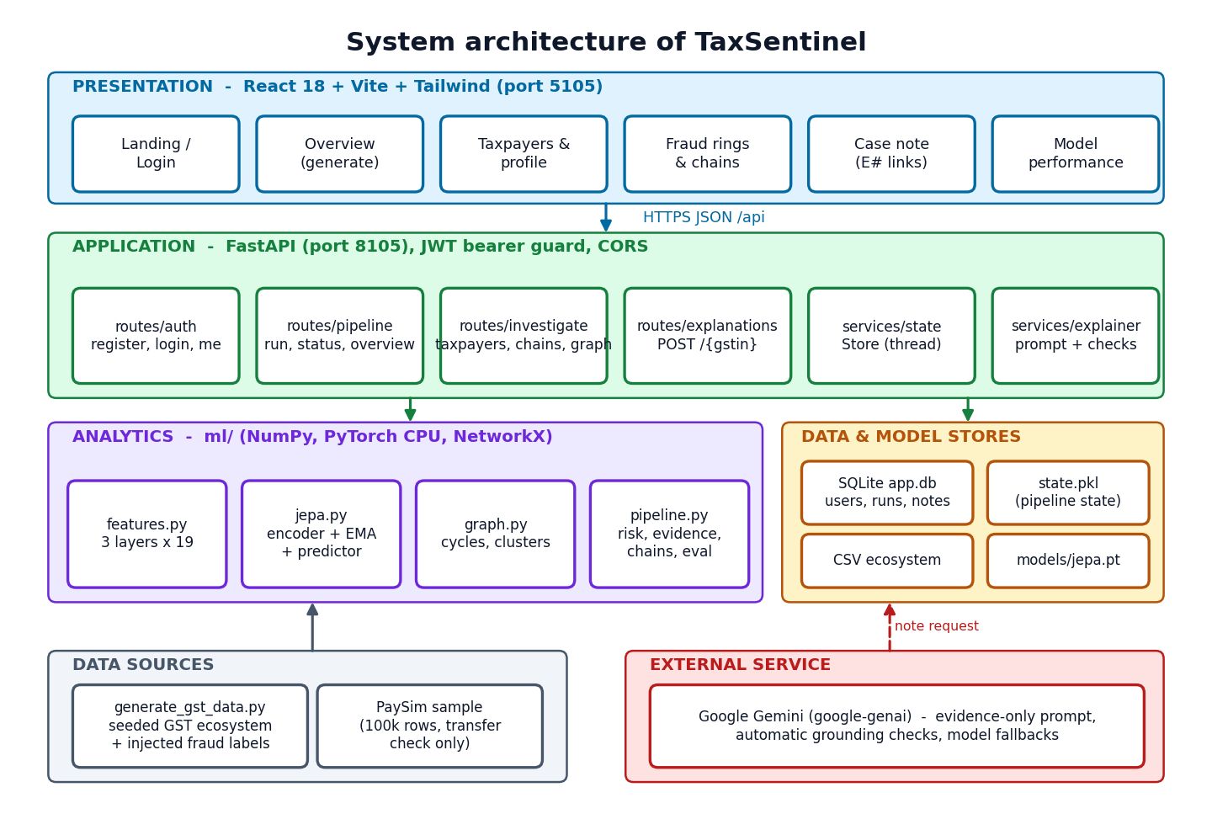
Figure 1: System architecture of TaxSentinel
Two design decisions shape the architecture. First, the analytical result is computed once per ecosystem and held in memory (and pickled to data/workspace/state.pkl), so every read endpoint is a lookup rather than a computation; this is why the read endpoints respond in milliseconds. Second, long computations never run in a request: a generation is started on a background thread and the interface polls a status endpoint, which also feeds the stage stepper and the activity log.

5.6 Module Design
Table 1: Modules and responsibilities
Module | File(s) | Responsibility
Data generator | scripts/generate_gst_data.py (483 lines) | Seeded ecosystem with GSTIN-format ids, tiered supply network, returns, injected fraud and hard negatives
Feature builder | ml/features.py (169) | Loads the dataset; builds 19 features per taxpayer-month; robust scaler
JEPA | ml/jepa.py (149), ml/train.py (37) | Encoder, EMA target, predictor, sample construction, training, scoring, save and load
Network analysis | ml/graph.py (110) | Trade graph, bounded cycle search and scoring, ring merging, identity clusters, communities
Rule baseline | ml/baseline.py (45) | Rules R1-R5 used as the comparison
Metrics | ml/metrics.py (60) | Precision@k, recall@k, P/R/F1, ROC-AUC, average precision
Pipeline | ml/pipeline.py (530) | Deviation scoring, invoice scoring, risk, patterns, evidence, chains, evaluation
Evaluation | ml/eval.py (133) | Writes experiments/eval/metrics.json including the PaySim transfer and explanation checks
API | backend/app/ (main, auth, config, db, routes, services; 787 lines) | Endpoints, JWT guard, persistence, background runs, explainer
Web application | frontend/src/ (10 pages plus components, 1,415 lines in the pages; 3,774 lines in 36 source files overall) | Screens, charts, graph, navigation, themes

5.5 Database Design
Application data that changes at run time is stored in SQLite through SQLAlchemy; the analytical dataset is not, because it is read as a whole, is regenerated from a seed and is naturally columnar. Fig. 2 shows the three SQL tables and the three CSV entities that they refer to logically.
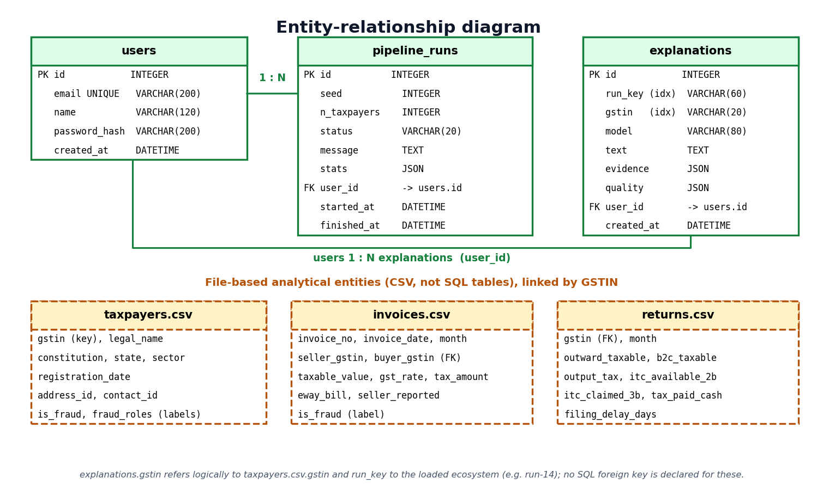
Figure 2: Entity-relationship diagram
Table 2: SQL tables
Table | Columns | Keys and notes
users | id, email, name, password_hash, created_at | PK id; email unique and indexed; password stored only as a bcrypt hash
pipeline_runs | id, seed, n_taxpayers, status, message, stats (JSON), user_id, started_at, finished_at | PK id; FK user_id to users; status is running, done or failed; stats holds the summary counts
explanations | id, run_key, gstin, model, text, evidence (JSON), quality (JSON), user_id, created_at | PK id; FK user_id to users; run_key and gstin indexed so a note is found for the loaded ecosystem; evidence is stored with the note so the citations stay valid

The CSV entities are taxpayers.csv (GSTIN, legal name, constitution, state, sector, registration date, address and contact identifiers, and the injected labels), invoices.csv (invoice number and date, seller and buyer GSTIN, taxable value, rate, tax, e-way bill flag, whether the seller reported it in GSTR-1, and the label) and returns.csv (monthly outward supplies, output tax, ITC available in GSTR-2B, ITC claimed in GSTR-3B, tax paid in cash and filing delay). The labels are carried in the files so that evaluation can run, but the model never reads them.

5.4 UML Diagrams
The class diagram (Fig. 3) shows three persistent classes (User, PipelineRun and Explanation), the Store service that holds the pipeline state and starts background runs, the pipeline and explainer modules, and the model classes JEPA, Encoder and RobustScaler. A JEPA instance owns two encoders, the online one and the exponential-moving-average target.
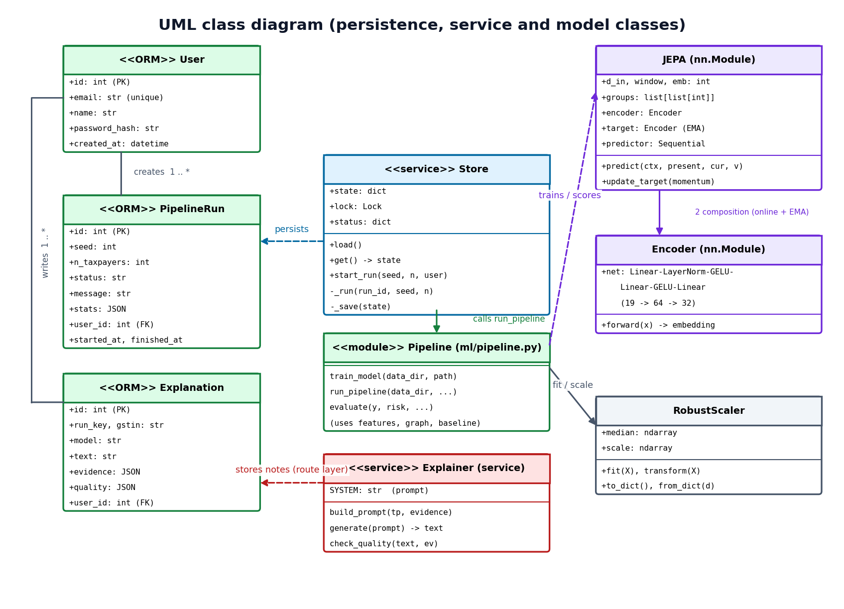
Figure 3: UML class diagram
The sequence diagram (Fig. 4) follows the main flow: sign-in, generating an ecosystem (the interface polls while a background thread runs the pipeline and updates the run row), opening the top taxpayer, and writing an explanation (the API builds the prompt from the evidence, calls Gemini, checks the grounding of the answer and saves it).
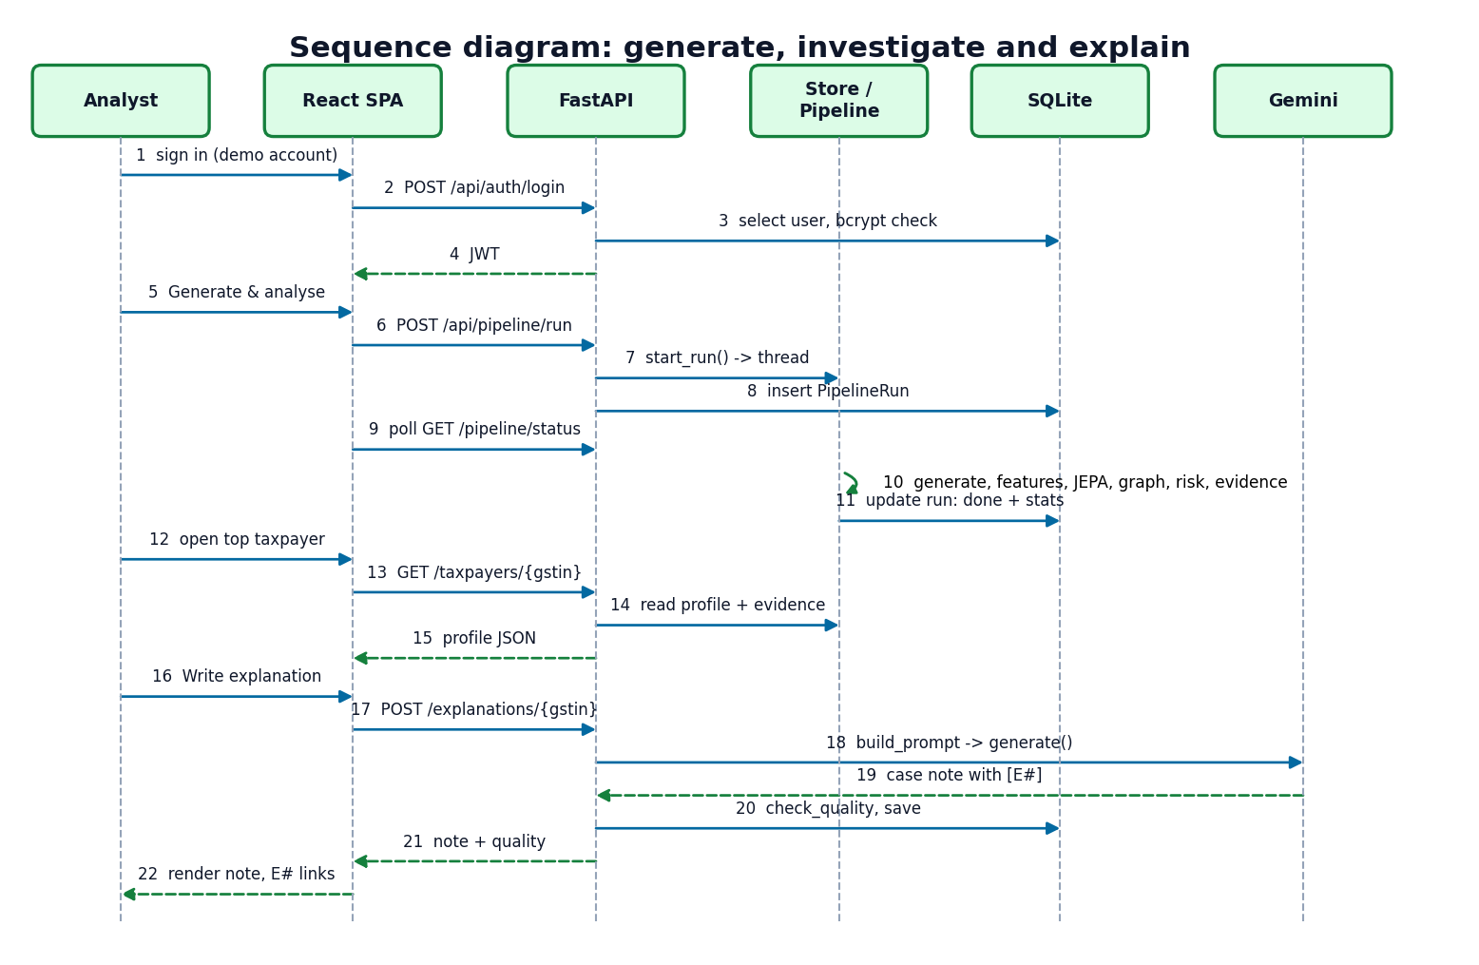
Figure 4: Sequence diagram of the main flow
The use-case diagram (Fig. 5) has the analyst as the primary actor and Gemini as a secondary actor of the case-note use case.
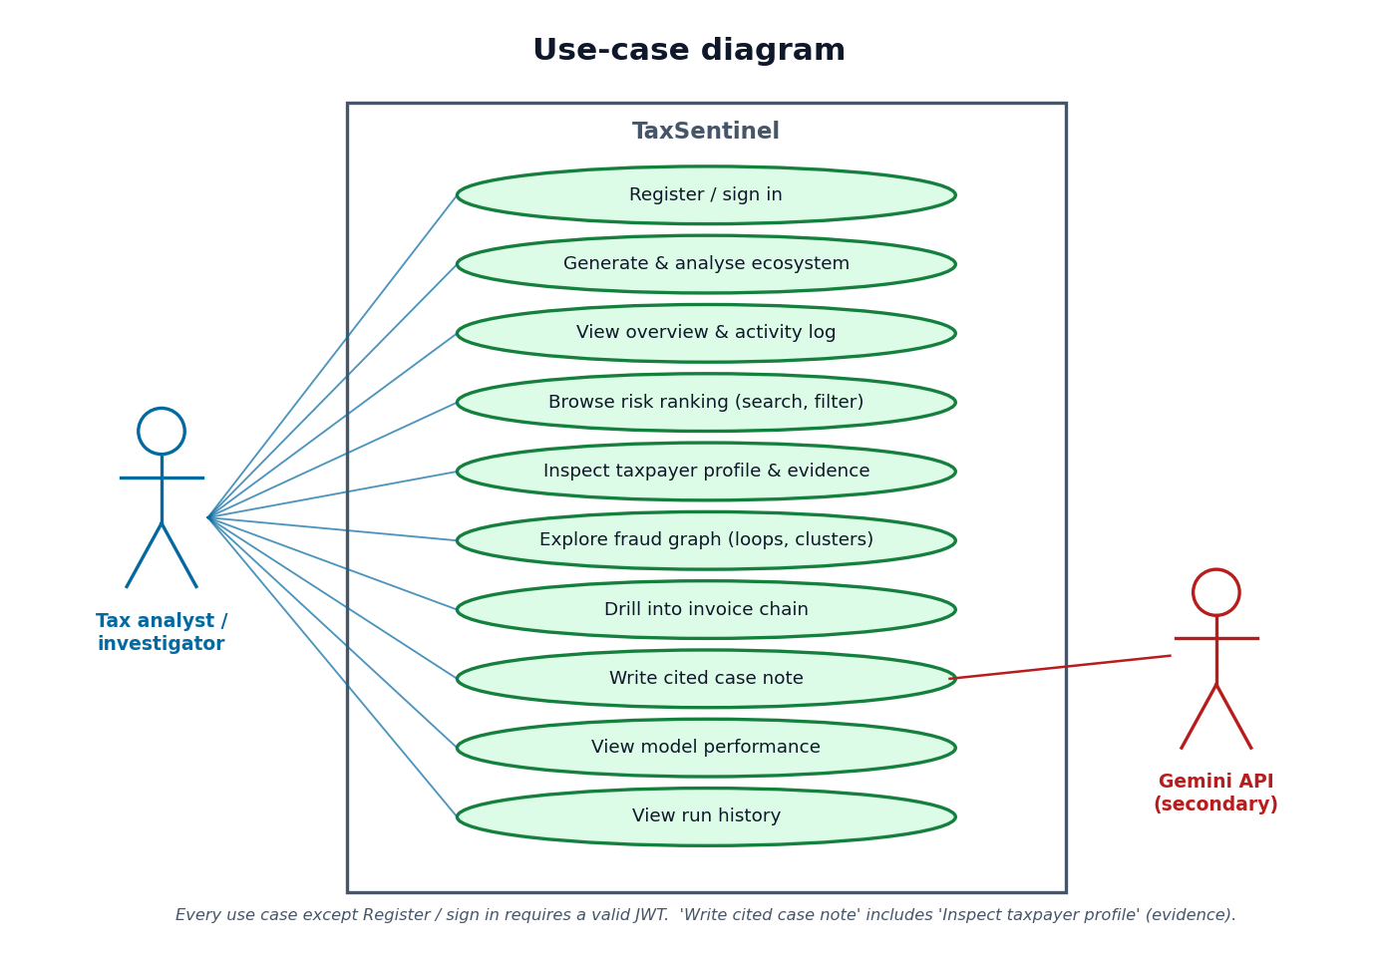
Figure 5: Use-case diagram

6.9 Application Architecture
The backend is a FastAPI application. At start-up it creates the SQLite tables, seeds the demo account and loads the pipeline state in a background thread (from the pickle if present, otherwise by running the pipeline on the bundled ecosystem). Five routers expose the API. The Store object holds the current state and the status of the running generation; a generation runs in its own thread, writes a pipeline_runs row with status running, done or failed, and replaces the in-memory state atomically (the pickle is written to a temporary file and renamed). The frontend is a React single-page application with route-level code splitting: each screen is its own bundle, loaded when first visited. Axios calls the API, and the Vite development server proxies /api to port 8105.

6.10 API Design
Table 3: REST endpoints (all except register, login and health require a bearer token)
Method | Path | Purpose
POST | /api/auth/register, /api/auth/login | Create an account / sign in; returns a JWT and the user
GET | /api/auth/me | Current user
POST | /api/pipeline/run | Start a generation: seed (0 to 10,000,000), taxpayers (150 to 1,500); 409 if one is running
GET | /api/pipeline/status, /api/pipeline/runs | Progress of the running generation / the last ten runs
GET | /api/overview, /api/overview/monthly | Dashboard data / monthly ITC series
GET | /api/taxpayers | Ranking with q, pattern, flagged, sector, sort, limit (1 to 500) and offset
GET | /api/taxpayers/{gstin} | Profile: scores, evidence, partners, anomalous invoices, monthly series, stored note
GET | /api/chains, /api/chains/{id} | Invoice chains / chain with its invoices and parties
GET | /api/structures, /api/graph | Rings and clusters / graph data (focus, ring, cluster or chain)
POST | /api/explanations/{gstin} | Write and store a cited case note; 400 if no evidence, 502 if Gemini fails
GET | /api/metrics, /api/health | Evaluation and training reports / service status (public)

Requests and responses are JSON. Request bodies are validated by pydantic models, which return HTTP 422 with a description for bad input. Errors use conventional statuses: 401 for a missing or invalid token, 404 for an unknown GSTIN or chain, 409 for a duplicate account or a second concurrent run, 502 for an upstream failure and 503 while the state is still loading.

6.11 Security and Error Handling
- Passwords are hashed with bcrypt [28] with a per-password salt; the plaintext is never stored or logged.
- Sessions are signed HS256 JSON Web Tokens [27] that expire after 720 minutes; an altered signature is rejected (tested). The signing secret is generated by setup.bat and kept in the untracked .env.
- Authorisation. Every analytical endpoint depends on the current_user guard; the public endpoints are register, login and health only.
- Input validation. E-mail format, password length (8 or more), seed and taxpayer-count ranges and paging limits are validated before use. Database access goes through SQLAlchemy with bound parameters, and the search text is only used as a string comparison on in-memory data; SQL-injection-style and script-tag search text were tested and are inert.
- Cross-origin access is limited to the configured frontend origins.
- Secrets. The Gemini key and JWT secret live in .env, which is excluded from version control.
- Failure handling. The Gemini client retries once on a busy or rate-limit response, falls back to alternative models, and finally returns a readable error to the interface; a failed generation is recorded with status failed and its message.
- Not implemented. Rate limiting, account lockout, role-based access control, HTTPS termination (the API is served over HTTP on the local machine) and audit logging of reads are not implemented and would be required for deployment.

5.7 User Interface Design
The interface is a "control room" for an analyst. Its main design rules are: show the answer before the mechanism (the overview leads with counts, flagged taxpayers and the comparison with the baseline); let every number lead to its evidence (a taxpayer opens a profile, a citation chip jumps to its evidence item, a chain opens its invoices); keep the system status visible (a health card, a stage stepper, an activity log); and respect the user's environment (light and dark themes following the operating-system setting, reduced-motion support, keyboard navigation with a command palette and g shortcuts). The screens are presented in Chapter 8 and Appendix C.
Table 4: Screens and their purpose
Screen | Route | Purpose
Landing | / | What the product does; live health card
Sign in / register | /login | JWT sign-in, demo account
Overview | /app | Generate and analyse; counts; flagged taxpayers; patterns; top chains; activity log
Taxpayers | /app/taxpayers | Ranked list with search and filters
Taxpayer profile | /app/taxpayers/:gstin | Signals, evidence, network, invoices
Case | /app/cases/:gstin | Evidence list and the cited case note
Fraud rings | /app/graph | Interactive network; loops and clusters
Invoice chain | /app/chains/:id | Chain graph, parties and invoices
Model performance | /app/performance | Metrics, ablations, per-pattern recall
Run history | /app/runs | Last ten generations and the loaded ecosystem

Key Code Walkthroughs

Walkthrough 1: the JEPA model (ml/jepa.py)
The model keeps two copies of the encoder and a predictor. keep is a (variants x features) mask: row 0 hides everything, row k hides feature group k. predict encodes the three previous months (zeroed where a month is absent), encodes the current month with the mask applied, appends a one-hot of the variant and lets the predictor output the embedding of the full current month. update_target implements the exponential moving average.
class JEPA(nn.Module):
def __init__(self, d_in, groups, window=3, hidden=64, emb=32):
super().__init__()
self.d_in, self.window, self.emb = d_in, window, emb
self.groups = [list(g) for g in groups]
keep = torch.ones(len(groups) + 1, d_in)
keep[0] = 0
for k, g in enumerate(self.groups):
keep[k + 1, g] = 0
self.register_buffer("keep", keep)
self.encoder = Encoder(d_in, hidden, emb)
self.target = copy.deepcopy(self.encoder)
for p in self.target.parameters():
p.requires_grad_(False)
n_var = len(groups) + 1
self.predictor = nn.Sequential(nn.Linear(window * (emb + 1) + emb + n_var, 128), nn.GELU(),
nn.Linear(128, 128), nn.GELU(), nn.Linear(128, emb))

@property
def n_variants(self):
return len(self.groups) + 1

def predict(self, ctx, ctx_present, cur, variant):
b = cur.shape[0]
parts = []
if self.window:
h = self.encoder(ctx.reshape(-1, self.d_in)).reshape(b, self.window, self.emb)
h = h * ctx_present.unsqueeze(-1)
parts += [h.reshape(b, -1), ctx_present]
parts += [self.encoder(cur * self.keep[variant]), F.one_hot(variant, self.n_variants).float()]
return self.predictor(torch.cat(parts, dim=1))

@torch.no_grad()
def update_target(self, momentum):
for p, q in zip(self.encoder.parameters(), self.target.parameters()):
q.mul_(momentum).add_(p.detach(), alpha=1 - momentum)

The training loop draws a random mask variant per sample, computes the target with no gradient, adds the variance hinge and updates the target encoder after every step.
def train_jepa(ctx, ctxp, cur, groups, window, epochs=40, batch=256, lr=1e-3, seed=42, ema=0.99,
var_weight=1.0, progress=None):
torch.manual_seed(seed)
np.random.seed(seed)
model = JEPA(cur.shape[1], groups, window)
opt = torch.optim.AdamW([p for p in model.parameters() if p.requires_grad], lr=lr, weight_decay=1e-4)
tc, tp, tx = torch.from_numpy(ctx), torch.from_numpy(ctxp), torch.from_numpy(cur)
n = len(tx)
g = torch.Generator().manual_seed(seed)
history = []
t0 = time.time()
for ep in range(epochs):
perm = torch.randperm(n, generator=g)
tot, nb = 0.0, 0
for s in range(0, n, batch):
idx = perm[s:s + batch]
c, p, x = tc[idx], tp[idx], tx[idx]
variant = torch.randint(0, model.n_variants, (len(idx),), generator=g)
pred = model.predict(c, p, x, variant)
with torch.no_grad():
target = model.target(x)
loss_pred = F.mse_loss(pred, target)
z = model.encoder(x)
loss_var = F.relu(1 - z.std(dim=0)).mean()
loss = loss_pred + var_weight * loss_var
opt.zero_grad()
loss.backward()
opt.step()
model.update_target(ema)
tot += loss_pred.item()
nb += 1
history.append(round(tot / nb, 5))
if progress:
progress(ep + 1, epochs, history[-1])
return model, dict(epochs=epochs, batch=batch, lr=lr, ema=ema, window=window, samples=n,
loss_history=history, final_loss=history[-1], train_seconds=round(time.time() - t0, 1))

Walkthrough 2: from prediction error to a deviation score (ml/pipeline.py)
The error of every variant is normalised by the median over taxpayers of the same month; the variants are combined by a geometric mean; the taxpayer's raw score is the mean of its two worst months; _calibrate turns it into a 0-1 score with a robust z and a logistic.
def _calibrate(log_values, centre=2.0):
"""Robust z-score against the population, squashed to 0-1 (0.5 at `centre` robust SDs)."""
med = np.median(log_values)
mad = np.median(np.abs(log_values - med)) * 1.4826 + 1e-9
return 1 / (1 + np.exp(-1.5 * ((log_values - med) / mad - centre)))

Z = scaler.transform(X)
ii, mm, ctx, ctxp, cur = J.make_samples(Z, present, WINDOW)
errs = J.score(model, ctx, ctxp, cur)
V = errs.shape[1]
E = np.full((n, T, V), np.nan)
E[ii, mm] = errs
ratio = E / np.nanmedian(E, axis=0, keepdims=True) # error relative to a typical taxpayer in that month
with warnings.catch_warnings(): # months with no return are all-nan by design
warnings.simplefilter("ignore", RuntimeWarning)
month_ratio = np.exp(np.nanmean(np.log(ratio), axis=2)) # geometric mean over mask variants
raw = np.array([np.mean(sorted(month_ratio[i][present[i]], reverse=True)[:2]) if present[i].any() else 1.0
for i in range(n)])
logs = np.log(raw)
j_score = _calibrate(logs)
# behaviour-layer deviation: how badly the return figures disagree with what the
# invoice/network layers and the taxpayer's history predict (catches one-month ITC spikes)
b_raw = np.array([np.nanmax(ratio[i, :, 1 + GROUPS.index("behaviour")]) if present[i].any() else 1.0
for i in range(n)])
b_score = _calibrate(np.log(b_raw))

Walkthrough 3: circular-trading detection (ml/graph.py)
Only recurring, above-median edges are kept. simple_cycles with a length bound enumerates the loops; each is scored by balance, recurrence and concentration; overlapping suspicious loops are merged into rings by union-find.
def detect_cycles(G, purchases_total, max_len=5, cap=20000, min_score=0.25):
"""Find short trade cycles and score how much they look like circular trading.

balance - circulated values stay similar around the loop (min/max edge value)
recurrence - the whole loop trades in the same months, month after month
concentration - the loop is a large part of every member's purchases (not incidental)
"""
values = np.array([d["value"] for _, _, d in G.edges(data=True)])
thr = float(np.percentile(values, 50)) if len(values) else 0
H = nx.DiGraph()
H.add_edges_from((u, v) for u, v, d in G.edges(data=True) if len(d["months"]) >= 2 and d["value"] >= thr)
cycles = []
for k, cyc in enumerate(nx.simple_cycles(H, length_bound=max_len)):
if k >= cap:
break
edges = [(cyc[i], cyc[(i + 1) % len(cyc)]) for i in range(len(cyc))]
vals = [G[u][v]["value"] for u, v in edges]
common = set.intersection(*[G[u][v]["months"] for u, v in edges])
balance = min(vals) / max(vals)
recurrence = min(1.0, len(common) / 3)
conc = float(min(G[u][v]["value"] / max(purchases_total[v], 1) for u, v in edges))
score = balance ** 0.5 * recurrence * min(1.0, conc) ** 0.5
cycles.append(dict(nodes=list(cyc), edges=edges, value=float(sum(vals)), balance=round(balance, 3),
common_months=sorted(common), concentration=round(conc, 3), score=round(score, 3)))
suspicious = [c for c in cycles if c["score"] >= min_score]
# merge overlapping suspicious cycles into rings
parent = {}

def find(x):
while parent.setdefault(x, x) != x:
x = parent[x]
return x

for c in suspicious:
for v in c["nodes"][1:]:
parent[find(v)] = find(c["nodes"][0])
groups = defaultdict(list)
for c in suspicious:
groups[find(c["nodes"][0])].append(c)
rings = []
for cs in sorted(groups.values(), key=lambda cs: -max(c["score"] for c in cs)):
nodes = sorted({v for c in cs for v in c["nodes"]})
edges = sorted({e for c in cs for e in c["edges"]})
best = max(cs, key=lambda c: c["score"])
rings.append(dict(id=f"R{len(rings) + 1:02d}", nodes=nodes, edges=edges, score=best["score"],
best_cycle=best["nodes"], balance=best["balance"], common_months=best["common_months"],
value=float(sum(G[u][v]["value"] for u, v in edges)),
tax=float(sum(G[u][v]["tax"] for u, v in edges)), n_cycles=len(cs)))
return dict(n_cycles_scanned=len(cycles), truncated=len(cycles) >= cap, rings=rings)

Walkthrough 4: invoice scoring and the combined risk (ml/pipeline.py)
Each invoice collects flags; its score is the noisy-OR of the flag weights. Taxpayer layer scores are then combined with a weighted noisy-OR.
for r in invoices:
s, b, m, v = r["_s"], r["_b"], r["_m"], r["taxable_value"]
fl = []
if not r["seller_reported"]:
fl.append("unreported")
if goods[s] and v >= 50000 and not r["eway_bill"]:
fl.append("no_eway")
if v % 10000 == 0:
fl.append("round_value")
if (date.fromisoformat(r["invoice_date"]) - reg[s]).days < 180:
fl.append("young_supplier")
if s in susp_cluster_nodes:
fl.append("shell_cluster")
exposure_val[b, m] += v
if vanished[s]:
fl.append("supplier_vanished")
if (s, b) in ring_edges:
fl.append("ring_edge")
if v > 4 * seller_med[s] and v > 200000:
fl.append("value_spike")
sc = 1 - float(np.prod([1 - INVOICE_FLAGS[f][0] for f in fl])) if fl else 0.0
r["anomaly"], r["flags"] = round(sc, 3), fl
for who in (s, b):
total_val[who, m] += v
if sc >= INVOICE_FLAG_THRESHOLD:
flagged_val[who, m] += v
inbound[b].append(r["id"])
outbound[s].append(r["id"])
with np.errstate(invalid="ignore", divide="ignore"):
flagged_share = np.nan_to_num(flagged_val / total_val)
exposure = np.nan_to_num(exposure_val / F["purch_v"])
i_score = np.minimum(1, 1.5 * flagged_share.max(axis=1))

# ---------- combine layers ----------
_progress(progress, "risk", 90, "combining layers")
n_score = np.zeros(n)
for v in range(n):
parts = [min(1.0, 2 * exposure[v].max())]
if ring_of[v]:
parts.append(max(r["score"] for r in ring_of[v]))
if v in cluster_of and cluster_of[v]["suspicious"]:
parts.append(cluster_of[v]["score"])
n_score[v] = max(parts)
risk = 1 - ((1 - RISK_WEIGHTS["jepa"] * j_score) * (1 - RISK_WEIGHTS["behaviour"] * b_score)
* (1 - RISK_WEIGHTS["network"] * n_score) * (1 - RISK_WEIGHTS["invoice"] * i_score))
flagged = risk >= FLAG_THRESHOLD
base_hits, base_score = rule_baseline(ret, reg_age, present)

Walkthrough 5: the grounding check for case notes (backend/app/services/explainer.py)
After Gemini answers, check_quality extracts the citations, counts the invalid ones, computes the evidence and high-severity coverage and the share of numbers in the text that occur in the evidence.
def check_quality(text, evidence):
"""Grounding checks: citation validity/coverage and whether the numbers used appear in the evidence."""
ids = {e["id"] for e in evidence}
cited = re.findall(r"\[(E\d+)\]", text)
valid = [c for c in cited if c in ids]
high = {e["id"] for e in evidence if e["severity"] == "high"}
ev_text = " ".join(e["title"] + " " + e["detail"] for e in evidence)
ev_nums = {n.replace(",", "") for n in NUM_RE.findall(ev_text)}
body = re.sub(r"\[E\d+\]", "", text)
nums = [n.replace(",", "") for n in NUM_RE.findall(body) if len(n.replace(",", "").replace(".", "")) >= 2]
grounded = [n for n in nums if n in ev_nums]
sections = all(h in text for h in ("## Summary", "## Why it was flagged", "## Suggested next steps"))
return dict(
citations=len(cited),
invalid_citations=len(cited) - len(valid),
evidence_coverage=round(len(set(valid)) / len(ids), 3) if ids else None,
high_severity_coverage=round(len(set(valid) & high) / len(high), 3) if high else None,
numbers=len(nums), numbers_grounded=len(grounded),
numeric_grounding=round(len(grounded) / len(nums), 3) if nums else 1.0,
has_sections=sections, words=len(body.split()))

Walkthrough 6: authentication guard (backend/app/auth.py)
Every protected route depends on current_user, which decodes the bearer token, rejects bad or expired tokens with 401 and loads the user.
def current_user(creds: HTTPAuthorizationCredentials = Depends(bearer), db: Session = Depends(get_db)) -> User:
if not creds:
raise HTTPException(401, "Not signed in")
try:
uid = int(jwt.decode(creds.credentials, JWT_SECRET, algorithms=["HS256"])["sub"])
except jwt.PyJWTError:
raise HTTPException(401, "Session expired - please sign in again")
user = db.get(User, uid)
if not user:
raise HTTPException(401, "User not found")
return user

Walkthrough 7: background generation (backend/app/services/state.py)
start_run refuses a second concurrent run, records a run row and starts a thread; _run generates the data, runs the pipeline with progress callbacks, saves the state atomically and records the outcome.
def start_run(self, seed, n_taxpayers, user_id):
with self.lock:
if self.status["running"]:
raise RuntimeError("A generation is already running")
db = SessionLocal()
run = PipelineRun(seed=seed, n_taxpayers=n_taxpayers, status="running", user_id=user_id)
db.add(run)
db.commit()
run_id = run.id
db.close()
self.status = dict(running=True, stage="generate", progress=1, message="generating ecosystem",
run_id=run_id, error=None)
threading.Thread(target=self._run, args=(run_id, seed, n_taxpayers), daemon=True).start()
return run_id

def _run(self, run_id, seed, n_taxpayers):
db = SessionLocal()
run = db.get(PipelineRun, run_id)
try:
out = os.path.join(WORKSPACE, f"run_{run_id}")
generate(seed, n_taxpayers, out)
self._progress("features", 10, "ecosystem generated")
state = run_pipeline(out, train=True, seed=seed, progress=self._progress,
save_model_to=os.path.join(out, "jepa.pt"))
state.update(run_key=f"run-{run_id}", run_id=run_id, generated_at=time.time(),
dataset=f"data/workspace/run_{run_id}")
self._save(state)
run.status, run.stats, run.message = "done", state["stats"], "complete"
self.status.update(running=False, stage="done", progress=100, message="complete")
except Exception as e:
log.exception("Pipeline run failed")
run.status, run.message = "failed", str(e)
self.status.update(running=False, stage="failed", error=str(e), message=str(e))
finally:
run.finished_at = now()
db.commit()
db.close()

Implementation Decisions and Reasons
The table below lists the main decisions, what else was possible and why the choice was made. Where an alternative was not tested, the table says so; the choice is then a design argument and not a measured result.
Table 5: Implementation decisions and their reasons
Decision | Alternatives considered | Reason
Synthetic seeded generator with hard negatives | Public tax datasets; scraping; hand-made sample | No real GST data is public; a seeded generator is reproducible, labelled and can include legitimate irregularity, so detection is not trivial
Small MLP JEPA (53,420 values), window of 3 months | Transformer encoder; larger window; autoencoder | About 7.0k taxpayer-months do not justify a large model; training takes 11.7 s on a CPU; the window covers a quarter. Alternatives were not trained, so this is a design choice, not a measured one
Four mask variants | Single whole-month masking | Hiding each feature layer lets a deviation be attributed to a layer, and the behaviour-block variant catches one-month ITC spikes
EMA target encoder and variance hinge | Stop-gradient only; contrastive negatives | Standard JEPA/BYOL/VICReg practice to prevent collapse without negatives
Median-normalised errors, geometric mean, top-2 months | Mean of raw errors | Different months and variants have different error scales; the top-2 rule responds to sustained or repeated deviation without being dominated by one noisy month
Explicit cycle search (length <= 5) on recurring, above-median edges | Graph neural network; node2vec | Exact, fast on this data and yields a loop that can be drawn and cited; no labels needed
Noisy-OR with four hand-set weights | Learned classifier; averaging | One strong layer should suffice; parameters are readable; no labels needed. Weakness: weights tuned on seed 42 (Chapter 8)
Pipeline state held in memory and pickled | Compute per request; SQL tables for results | Read endpoints become lookups (1.7 to 12 ms median); state is rebuilt on a regenerate
Generation on a background thread with a polled status | Celery/queue; synchronous request | No extra infrastructure for a single-user prototype; keeps requests short; powers the stage stepper. A queue is future work
SQLite via SQLAlchemy for users, runs and notes | PostgreSQL; files | Zero set-up for a Windows demo; ORM keeps a later move to a server database easy
JWT bearer tokens (HS256, 12 h) and bcrypt | Server-side sessions; Argon2 | Stateless API for the SPA; bcrypt is a well-established password scheme
Notes generated on demand, stored with their evidence and quality checks | Pre-generate for all flagged taxpayers | Saves free-tier quota; a stored note can always be audited against the evidence it was written from
Gemini with fallback models and one retry | Single model; local model | Free tier rate-limits and overloads (observed: 429, 503, 504); fallbacks improved completion but did not remove failures
React with route-level code splitting, react-force-graph for the network | Server-rendered pages; Cytoscape | Each screen loads only its code; the force graph handles hundreds of nodes smoothly

6.12 Installation and Execution
On Windows 10 or 11 with Python 3.11 or later, Node.js LTS and free ports 8105 and 5105: run setup.bat once (it creates a virtual environment, installs PyTorch's CPU build and the requirements, writes .env with a random JWT secret, trains the JEPA if the weights are missing and runs npm install), put GEMINI_API_KEY into .env, then run run.bat, which starts the API and the web server, waits for the pipeline to be ready and opens http://localhost:5105. The demo account is demo@taxsentinel.app. The full guide is Appendix B.

